**DAILY ONLINE ACTIVITIES SUMMARY**

|  |  |  |  |  |  |
| --- | --- | --- | --- | --- | --- |
| **Date:** | | **15/06/2020** | **Name:** | **JASLINE SHARON TAURO** | |
| **Sem & Sec** | | **4th sem, A Section** | **USN:** | **4AL18CS029** | |
| **Online Test Summary** | | | | | |
| **Subject** | **---** | | | | |
| **Max. Marks** | **---** | | **Score** | **---** | |
| **Certification Course Summary** | | | | | |
| **Course** | | Application Developer | | | |
| **Certificate Provider** | | **AWS Educate** | **Duration** | | **3.30 hrs.** |
| **Coding Challenges** | | | | | |
| **Problem Statement:**   1. Write a Java Program to find if string is K-Palindrome or not. | | | | | |
| **Status: EXECUTED** | | | | | |
| **Uploaded the report in GitHub** | | | **YES** | | |
| **If yes Repository name** | | | <https://github.com/jaslinesharontauro/JAVA_Prgms> | | |
| **Uploaded the report in slack** | | | **YES** | | |

Online Test Details: (Attach the snapshot and briefly write the report for the same)

Certification Course Details: (Attach the snapshot and briefly write the report for the same)

Coding Challenges Details: (Attach the snapshot and briefly write the report for the same)

CERTIFICATION COURSE DETAILS:

Today I have continued the course “Application Developer” by AWS Educate. In this course today I learnt about ‘Programing and Scripting’. In programing I learnt about .Net, c, c++, c#, java and python programing language. And in Scripting I learnt about CLI, JavaScript, PHP, PowerShell and Ruby. I have also successfully completed the Assessment regarding this module.

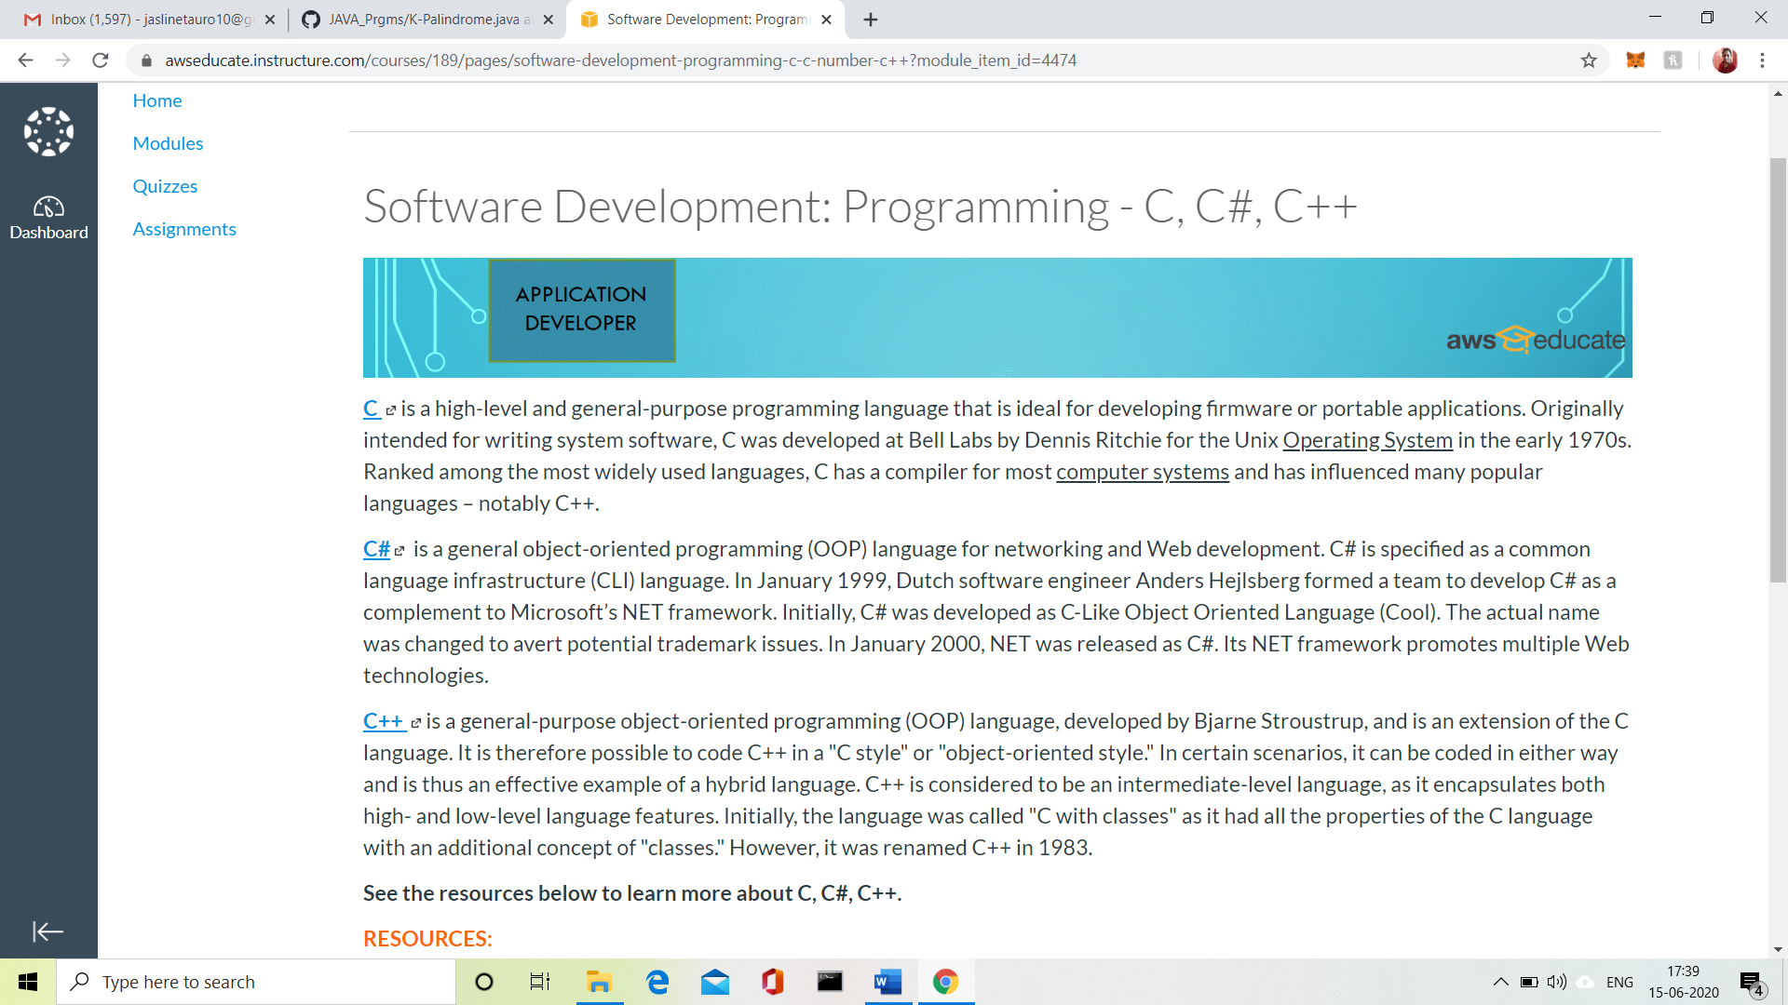

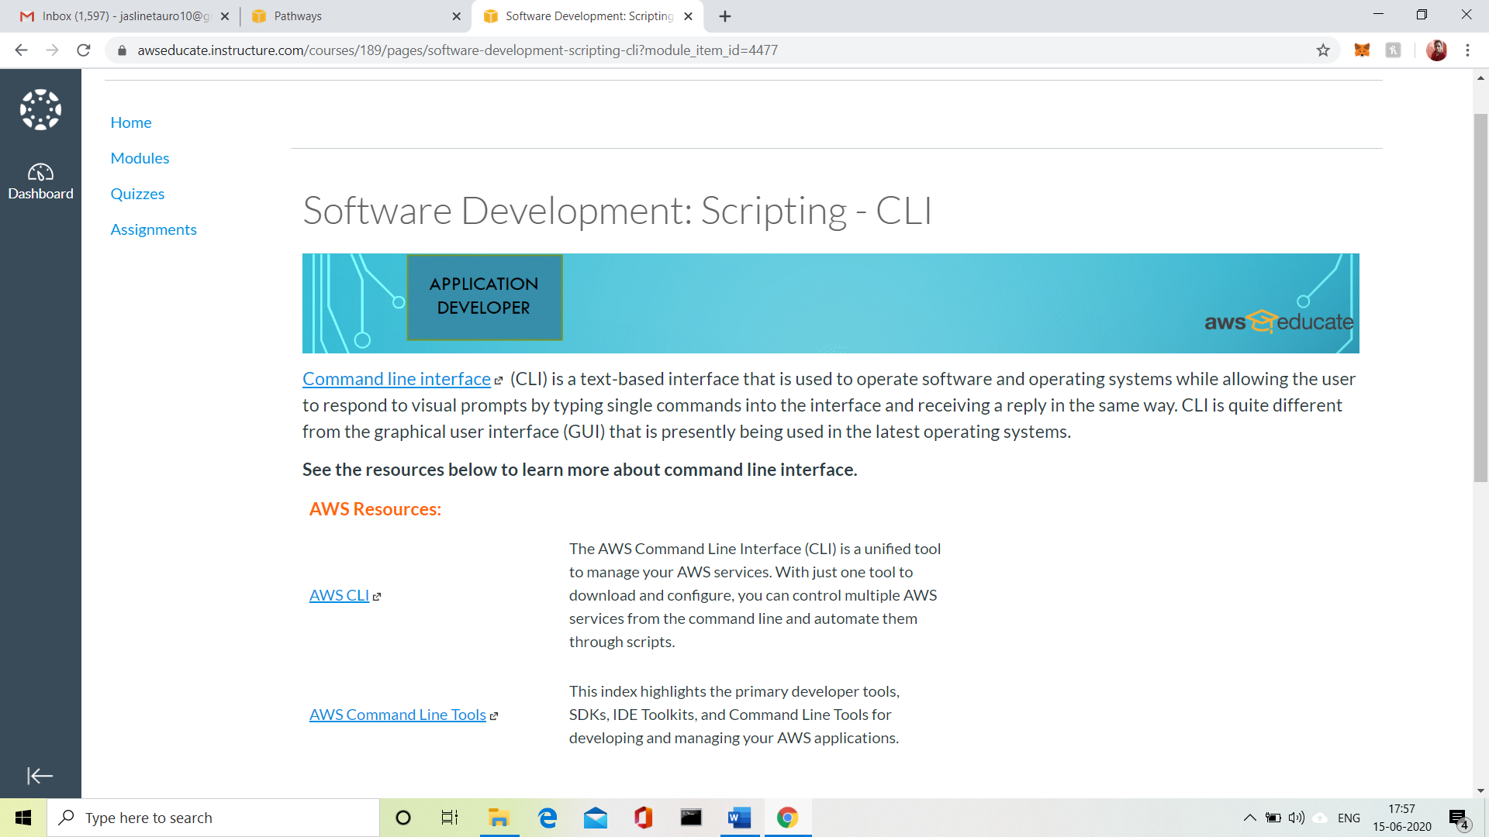

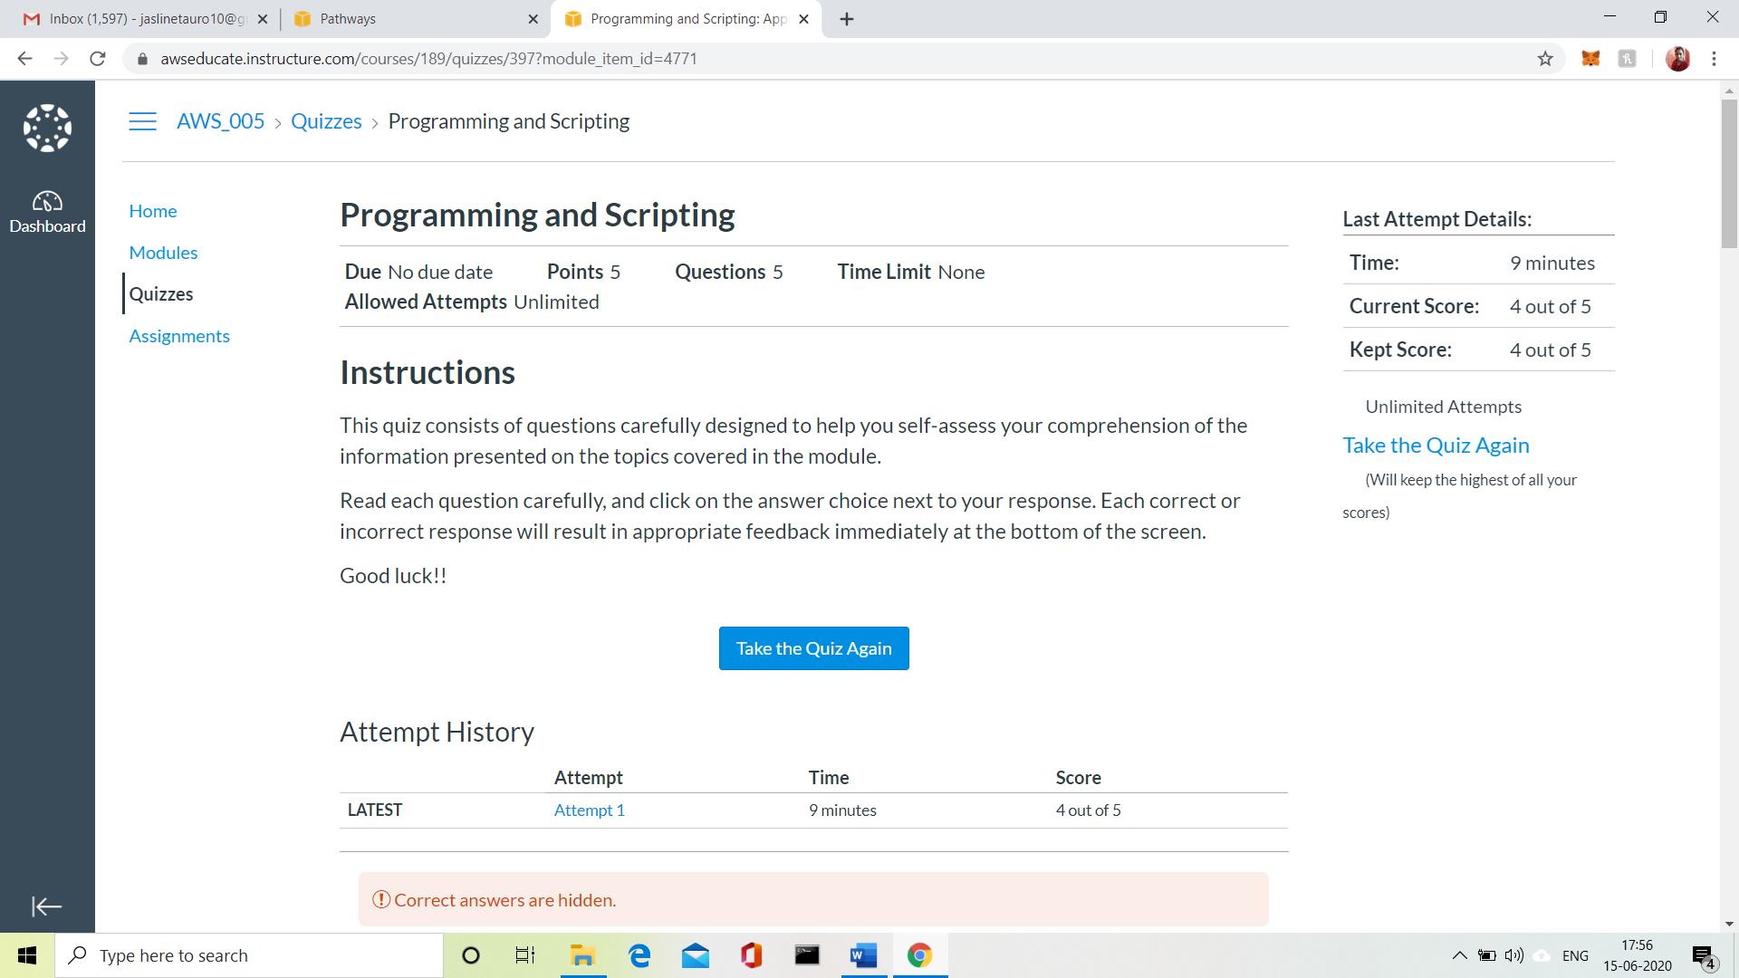

3.CODING CHALLENGES:

Problem Statement 1:

 Write a Java Program to find if string is K-Palindrome or not

A string is k palindrome if it can be transformed into a palindrome on removing at most k characters from it. Your task is to complete the function is_k_palin which takes two arguments a string str and a number N. Your function should return true if the string is k palindrome else it should return false.

Input:  
The first line of input is an integer T denoting the number of test cases. Then T test cases follow. Each test case contains a string str and an integer N separated by space.

Output:  
The output will be 1 if the string is k palindrome else 0.

**Example**  
Input: String - abcdecba, k = 1  
Output: Yes  
String can become palindrome by removing 1 character i.e. either d or e)

Input: String - abcdeca, K = 2  
Output: Yes  
Can become palindrome by removing  
2 characters b and e.

Input: String - acdcb, K = 1  
Output: No  
String cannot become palindrome by  
removing only one character.

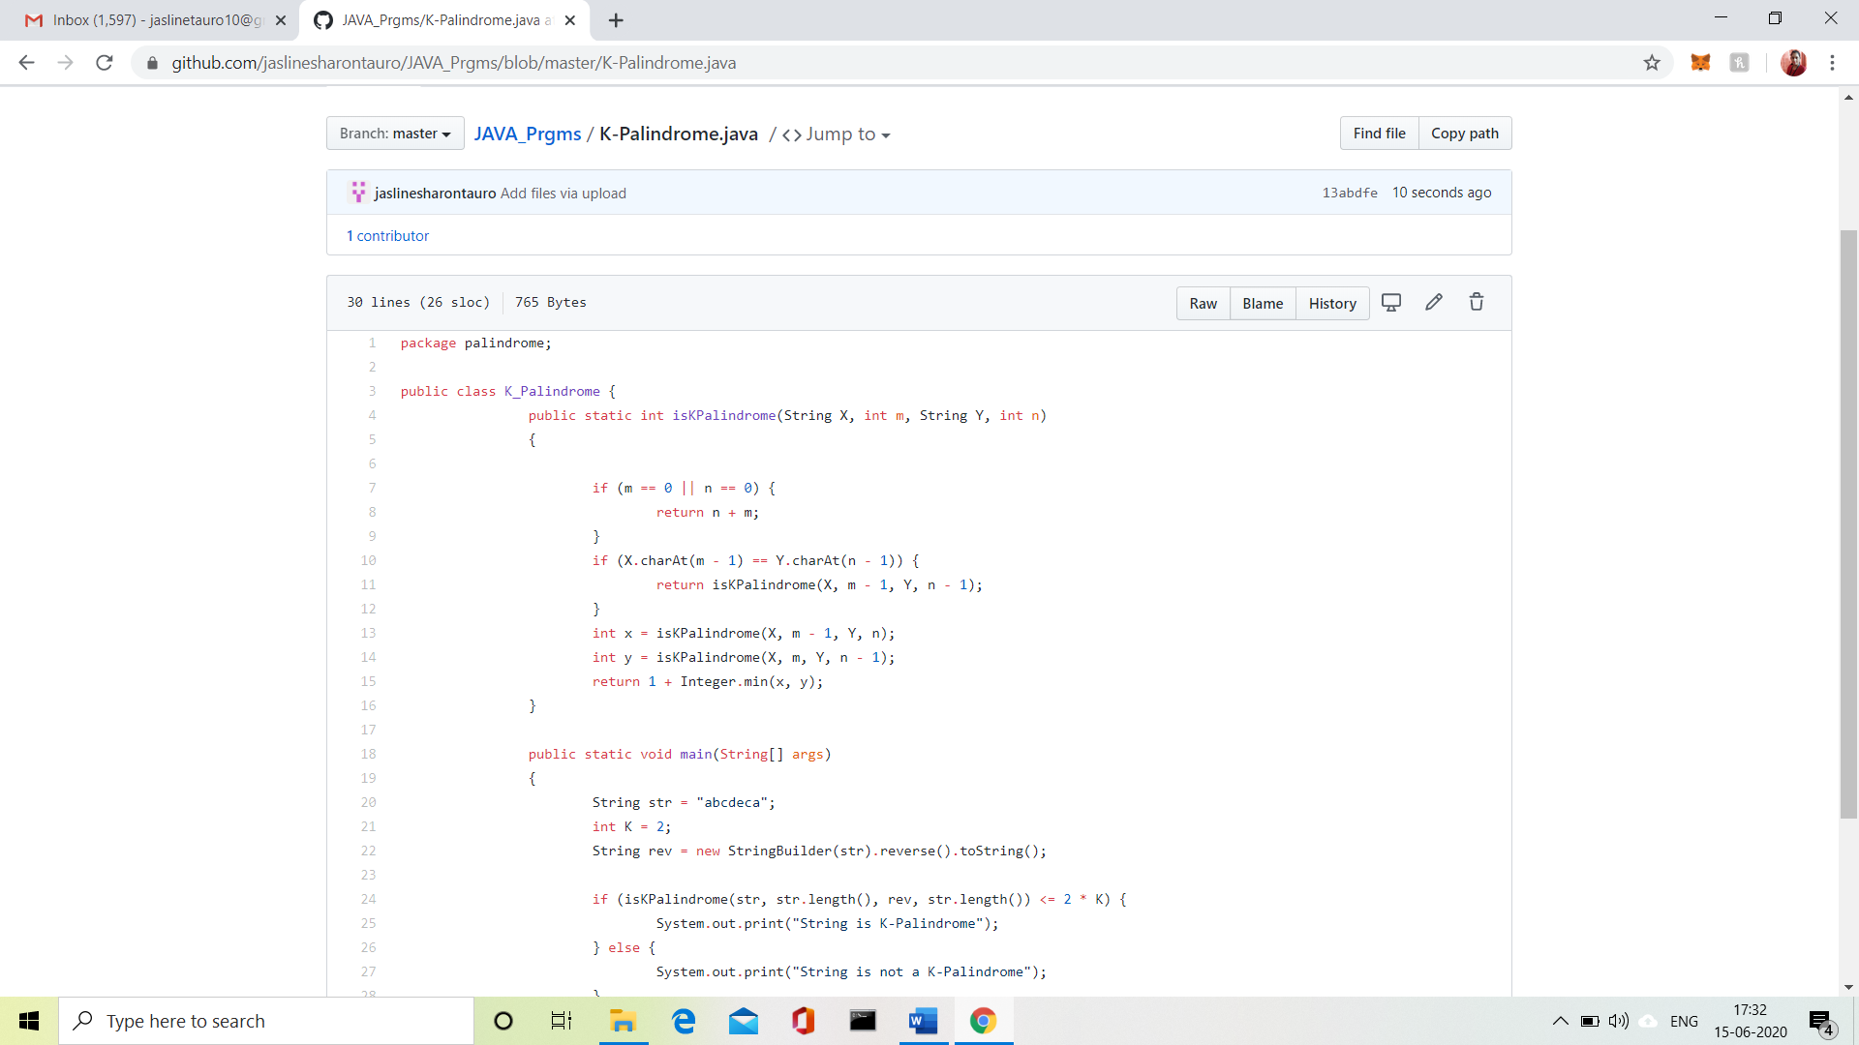

Solution uploaded in GitHub.